Guidelines for article submission to the Journal “Archivos de medicina del deporte”
Access to the article submission system through the following link:
http://archivosdemedicinadeldeporte.com/revista/index.php/amd/index
In case of being your first time in accessing the journal’s system, you must register. If the author already has a username and password, you must sign in and fulfil the username and password fields.
Once the author has signed in, in the main site, press on make a submission.
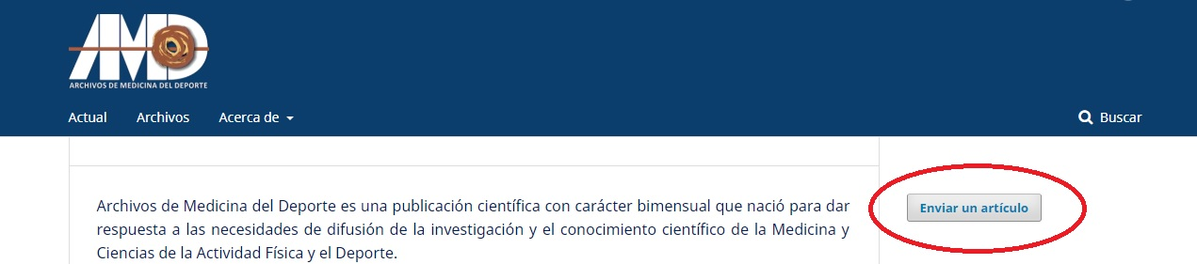
Now, language can be changed.
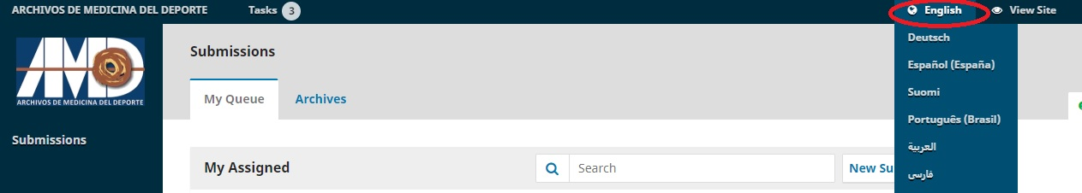
In the next step, after pressing new submission, author must mark all the checkboxes related to submission requirements.
In the section “Comments for the Editor”, authors must indicate if the article is an original or a review.
In the next section, press on upload file. For uploading every file, each item has to be uploaded individually.
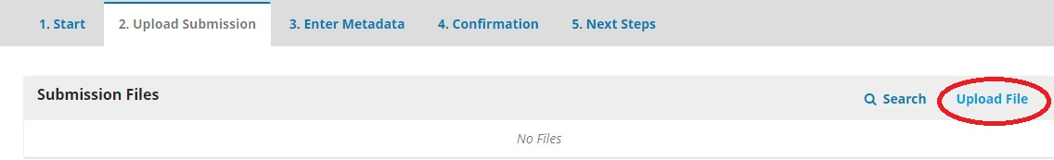
In the section “enter metadata”, autor must indicate the title of the article, abstract, name of the authors and key words.
Once the information and items regarding to the article are uploaded, authors must press finish submission.

